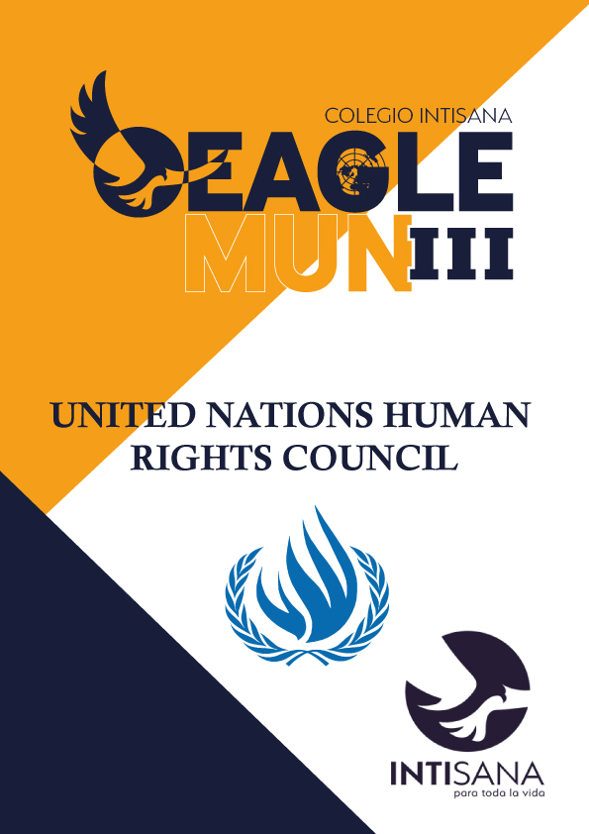

UNHRC Handbook - EagleMUN III
An introduction from the committee chairs:
Hello, delegates. We are Michael Conway and Luis Felipe Gonzáles. We are members of the Colegio Intisana Model United Nations club, and have been committee chair for many Human Rights Committees over the last years. I, Michael, currently reside in Washington D.C. where I am currently doing a year of service with AmeriCorps and working a job at night. And I, Luis Felipe, currently attend Universidad San Francisco de Quito, where I am studying music. Our expectations for this committee are high, since this is one of the most important committees of the United Nations, but likewise, we invite all of you to use this as a learning experience! Many of you might be experiencing this committee for the first time, and it will seem completely foreign to you at first. We are here if any of you have questions or doubts. Feel free to reach out for absolutely anything you may need. We try to create a feeling of friendliness with all my delegates outside the committee, but while in session, We are as formal as possible. We hope you all have a great experience during this MUN, and can’t wait to meet you all!
Committee Overview
The United Nations Human Rights Council (UNHRC) is an intergovernmental body of the United Nations, founded in 2006 through resolution 60/251 and it was designated the role of promoting the protection of human rights around the globe. The Human Rights council is made by 47 member states, all chosen by the United Nations General Assembly and it can discuss all human rights issues and situations that require its attention throughout the year. (Human Rights Council, 2020). Members of the council can only serve up to three years and only up to two consecutive periods. Within the Human Rights Council human rights violations committed by or in all member states of the United Nations are discussed: Sessions of the Council are held three times per year and serve as a forum for dialogue on pressing thematic and country-specific human rights issues facing the international community . The council is responsible for suggesting sanctions as well as measures to solve the different issues presented. The UNHCR works with "independent human rights experts with mandates to report and advise on human rights from a thematic or country-specific perspective" (OHCHR, 2021)

- Measures to prevent Kafala in Middle Eastern countries
The Kafala System originated in the 20th century in the Persian Gulf States as a form of allowing nations such as Qatar, United Arab Emirates, Saudi Arabia among others to increase their workforce for major infrastructure projects by bringing immigrants from neighboring nations such as Iraq, Egypt, or even from South East Asia and Africa. According to the United Nations Department of Economic and Social Affairs, it is estimated that around 36,000,000 immigrants are residing in Middle Eastern countries that implement the Kafala System. With the main issue being that the jurisdiction of this legal framework does not fall under the labor ministries of the nations who use it, which causes these immigrant workers to not receive any workers’ rights that should otherwise be granted to them, which is a clear violation of Article 25 of the United Nations Declaration of Human Rights. Most notoriously, Lebanon has been accused of having exploitation issues with its population of 250,000 migrant workers under Kafala, according to Human Rights Watch. Furthermore, these migrant workers, in many cases, suffer from exploitation, racism, and very low wages, due to many labor laws not applying to them. (Robinson, 2022)

The major boom in the Middle East’s economy, due to the ever growing oil industry in nations such as Saudi Arabia with 11 million migrant workers living under this system according to Amnesty International, or the FIFA World Cup in Qatar, have led to an increased demand for immigrant workers, which have been brought under contracts in which these migrant workers depend completely on their employer. A major example of this is the United Arab Emirates, which is a nation where over 90% of its population consists of foreign nationals who make extremely low wages, and are legally binded to the company they work for. Due to this dependence, they more often than not, are found in situations where they sign contracts that force them to live in dorm-like housing provided by their employer, binds them to their job and preventing them from leaving it without permission from the company, and most importantly, these contracts eliminate the ability to file a dispute or complaint to their employer when working conditions are hazardous or if there is any issue at all. These are rights guaranteed in many other parts of the world, which has led people to criticize this system as modern day slavery. (Reform the Kafala System)
- Measures to improve education in countries with scarce resources.
One of the United Nations’ Sustainable Development Goals for 2030 is to achieve access to good public education for all children in the world, but currently, nations with scarce resources are certainly falling short of the expectations set on them. According to the UNESCO Institute of Statistics, it is estimated that around 258 million children are not enrolled in school, this includes children of all ages ranging from primary all the way to late secondary school. This data was taken in 2018. These numbers are estimated to have increased dramatically since the outbreak of the Covid-19 Pandemic, which left many nations in severe lockdown in 2020. (Out-Of-School Children and Youth)

According to UNICEF, around 600 million children around the world cannot attain minimum levels of proficiency in mathematics, and reading, even considering that around 2 thirds of these children are in school. Nations with scarce resources are affected by issues of political instability, war, high crime rates, etc. For example, in Pakistan and Afghanistan, according to GlobalCitizen.org, the Taliban prevent over 25 million young girls from attending school due to their religious beliefs. According to UNICEF, around 2.4 million children in Syria do not have access to school due to the civil war that has been raging for over 10 years. According to the Coalition to Stop the Use of Child Soldiers, around 120,000 children under the age of 18 are involved in paramilitary groups in Sub-Saharan Africa, most of them against their will. It is estimated that around 40% of child soldiers are in Africa, and the nation with the highest number of child soldiers being the Democratic Republic of the Congo, according to World Vision Canada. All of these factors contribute to learning environments being severely affected. Last but not least, we must also note that around 2 thirds of the world’s youth, which amounts to around 1.08 Billion young people, does not have access to the Internet, which clearly became a necessity for schooling since the outbreak of Covid-19 in 2020, which has only crippled their learning ability even more. (UNICEF.org)

- Violation of Human Rights in the construction of stadiums and infrastructure for the Qatar 2022 World Cup.
According to the UN, all the unfair wages (if given), deaths and cruel work conditions should have been taken into consideration when assigning Qatar as the host country for such event as the World Cup. Seeing it had no previous preparation and in order to be ready for the date, Qatar had to build 9 stadiums, public transports systems, countless hotels and other forms of infrastructure required for the event. All this work was done while in the poorest work conditions and all around the year, which for the region means months of temperatures of up to 40º Celsius. The exact number of deceased due to extreme conditions has not been, and may never be, precisely calculated; but while FIFA and the Qatar government states there were 3, HRW estimates the numbers may be in the thousands. (Human Rights Watch, 2019)

FIFA’s fault can easily be spotted on all stages of the tournament’s evolution, for starters when Qatar was chosen as the host for the 2022 World Cup under suspicious circumstances losing the bid against a better prepared and clearly superior on all aspects United States. Then on 2016-2017 the organization adopted the United Nations Guiding Principles on Business and Human Rights into its Statutes, as well as its Human Rights Policy, admitting some blame on the facts but offering to repay and repair all harm. And now on its last stage, both FIFA and Qatar’s authorities have constantly tampering and censoring information relevant to finally reveal the real number of work related deaths, modern slavery cases and poverty/discrimination on the country. (Human Rights Watch, 2022)

Bibliography:
A rough guide to the human rights council. Universal Rights Group. (2020, March 20).
Retrieved December 6, 2022, from https://www.universal-rights.org/human-rights rough-guides/a-rough-guide-to-the-human-rights-council/
HRC Home. OHCHR. (n.d.). Retrieved December 6, 2022, from
https://www.ohchr.org/EN/HRBodies/HRC/Pages/Home.aspx

Robinson, Kali. “What Is the Kafala System?” Council on Foreign Relations, Council on Foreign Relations, 18 Nov. 2022, https://www.cfr.org/backgrounder/what-kafala-system.
“Reform the Kafala System.” Migrant Rights, 31 Mar. 2019, www.migrant-rights.org/campaign/end-the-kafala-system.

Out-of-School Children and Youth | UNESCO UIS. uis.unesco.org/en/topic/out-school-children-and-youth.

“Education.” UNICEF, www.unicef.org/education.
Human Rights Watch. (2022, November 14). Qatar: Rights Abuses Stain FIFA World Cup. Retrieved from Human Rights Watch: https://www.hrw.org/news/2022/11/14/qatar-rights-abuses-stain-fifa-world-cup
Human Rights Watch. (2019, October 10). Qatar: Urgently Investigate Migrant Worker Deaths. Retrieved from Human Rights Watch: https://www.hrw.org/news/2019/10/10/qatar-urgently-investigate-migrant-worker-deaths
Tarver, Brett. “Child Soldiers in Africa: Mukele's Story.” World Vision Canada, Organization, 13 July 2021, https://www.worldvision.ca/stories/child-protection/child-soldiers-in-africa-mukeles-story.
UNICEF. “After Almost Ten Years of War in Syria, More than Half of Children Continue to Be Deprived of Education.” UNICEF, https://www.unicef.org/press-releases/after-almost-ten-years-war-syria-more-half-children-continue-be-deprived-education.
Rueckert, Phineas. “10 Barriers to Education That Children Living in Poverty Face.” Global Citizen, https://www.globalcitizen.org/en/content/10-barriers-to-education-around-the-world-2/.

